**Lab 9 Activity 3 - Assigning Grades Using IF Function**

**Objective:** Implement conditional logic to assign letter grades.

1. In the Grade column, use the following IF function: =IF(I2<50,"F",IF(I2<60,"E",IF(I2<70,"D",IF(I2<80,"C",IF(I2<90, "B","A")))))
2. Press Enter and use the fill handle to apply it to other rows.
3. Apply conditional formatting to highlight failing students in red.
4. Save and close the file.

**____________________________________________________________________________________**

**Solutions:**

**Task 1:**

• Click on **Cell J2** (under the "Grade" column).

• Enter the following formula:

=IF(I2<50,"F",IF(I2<60,"E",IF(I2<70,"D",IF(I2<80,"C",IF(I2<90,"B","A")))))

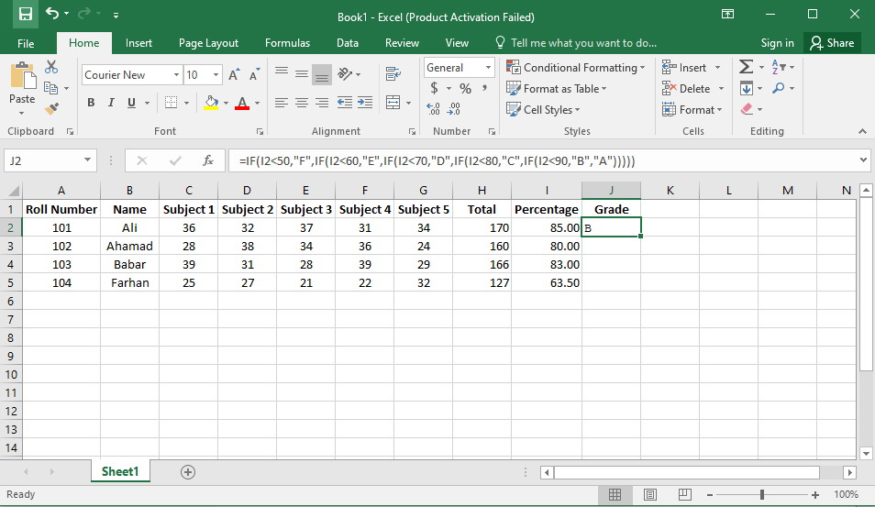

**Task 2:**

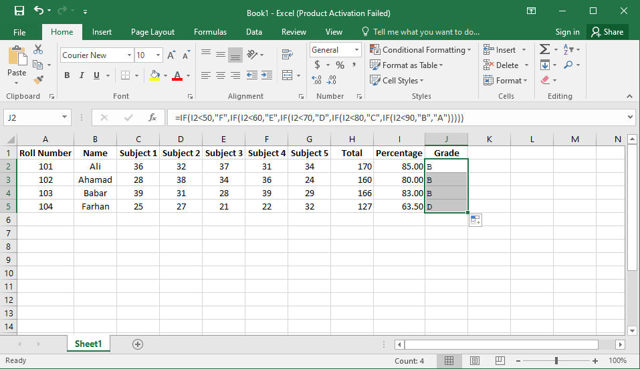• Press **Enter** and use the **fill handle** (drag the small square at the bottom-right of the cell) to copy the formula to other rows.

**Task 3:**

• Select the entire **Grade column** (e.g., **J2:J50**, depending on your data).

• Click **Home > Conditional Formatting > New Rule**.

• Choose **"Format cells that contain"**.

• In the **Format Cells dialog**, set the rule:

* **Format only cells that contain** → **Cell Value** → **Equal to** → Enter "B"
* Click **Format**, go to the **Fill** tab, and select **Light green color.**
* Click **OK**.

• Click **Apply** and **OK**.

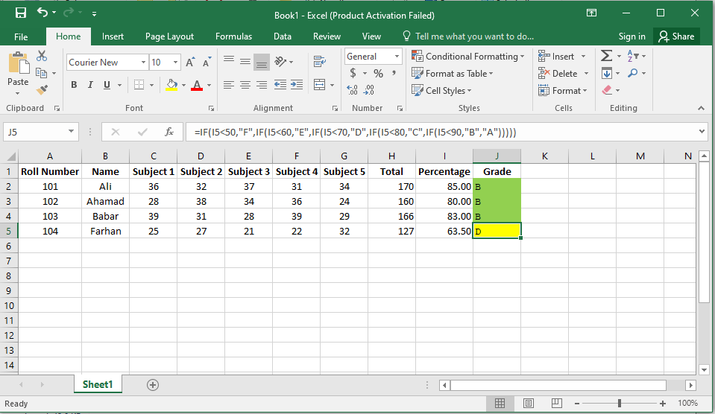

**Task 4:**

• Click **File > Save**.

• Close **Excel**.